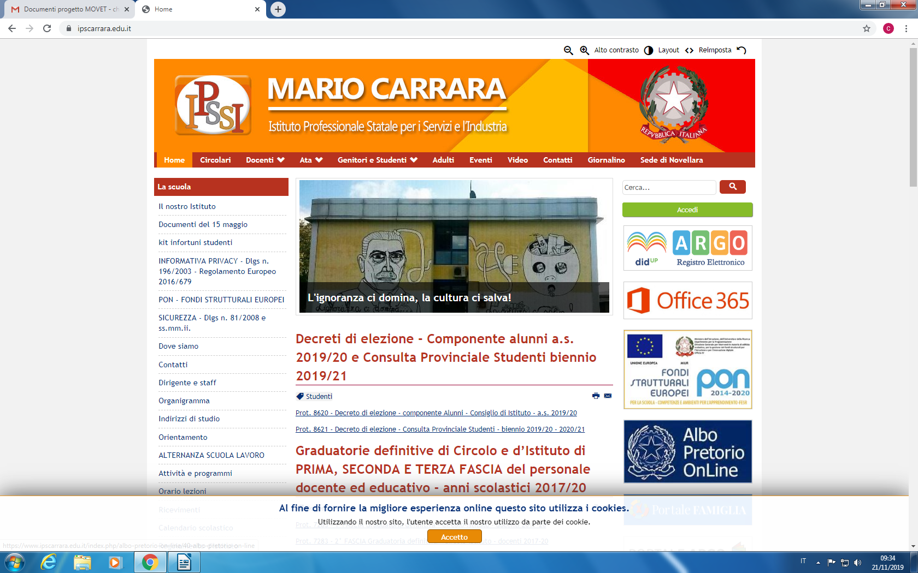

MODULO DI PREISCRIZIONE AL PROGETTO ERASMUS+
A.S. 2023-2024

NOME: ___________________________________________________________________

COGNOME: _______________________________________________________________

DATA DI NASCITA: ________________________________________________________

CLASSE: _______________

INDIRIZZO E-MAIL: ________________________________________________________

NUMERO DI CELLULARE: __________________________________________________

HAI LA CITTADINANZA ITALIANA? SÌ NO

HAI LA CITTADINANZA DI UN ALTRO PAESE EUROPEO? SÌ NO

FIRMA:

___________________________________________________________________________

ALLEGA AL PRESENTE MODULO:

- LA LETTERA MOTIVAZIONALE;

- UNA FOTOCOPIA (FRONTE E RETRO) DEL TUO PASSAPORTO (O DELLA TUA CARTA D’IDENTITÀ).

RICONSEGNA QUESTA DOCUMENTAZIONE ALLA PROF.SSA CHIARA CANOVA (O INVIALA ALL’INDIRIZZO ccanova@ipscarrara.it) ENTRO IL 22 DICEMBRE 2023.

ALLEGATO N.1

LETTERA MOTIVAZIONALE (in italiano)

Dopo una breve presentazione personale, motiva la scelta di candidarti al progetto Erasmus indicando le tue aspettative e le capacità che pensi di avere, necessarie per affrontare tale esperienza.
(Utilizza solo lo spazio sottostante)

________________________________________________________________________________________________________________________________________________________________________________________________________________________________________________________________________________________________________________________________________________________________________________________________________________________________________________________________________________________________________________________________________________________________________________________________________________________________________________________________________________________________________________________
___________________________________________________________________________________________________________________________________________________________________________________________________________________________________________________________________________________________________________________________________________________________________________________________________________________________________________________
________________________________________________________________________________________________________________________________________________________________________________________________________________________________________________________________________________________________________________________________________________________________________________________________________________________________________________________________________________________________________________________________________________________________________________________________________________________________________________________________________________________________________________________

